**Q.1 What is Apache Kafka?**

**Ans.** Apache Kafka is a publish-subscribe open source message broker application. This messaging application was coded in “**Scala**”. Basically, this project was started by the Apache software. Kafka’s design pattern is mainly based on the transactional logs design.

**Q.2 Enlist the several components in Kafka.**

**Ans.** The most important elements of Kafka are:

[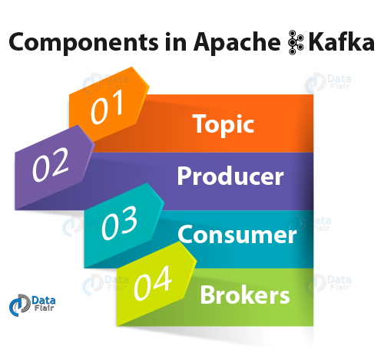](https://data-flair.training/blogs/wp-content/uploads/sites/2/2018/05/components-in-Apache-Kafka.png)

*Kafka Interview Questions- Components of Kafka*

* **Topic –**

Kafka Topic is the bunch or a collection of messages.

* **Producer –**

In Kafka, Producers issue communications as well as publishes messages to a Kafka topic.

* **Consumer –**

Kafka Consumers subscribes to a topic(s) and also reads and processes messages from the topic(s).

* **Brokers –**

While it comes to manage storage of messages in the topic(s) we use Kafka Brokers.

**Q.5 What is the role of the ZooKeeper in Kafka?**

**Ans.** Apache Kafka is a distributed system is built to use Zookeeper. Although, Zookeeper’s main role here is to build coordination between different nodes in a cluster. However, we also use Zookeeper to recover from previously committed offset if any node fails because it works as periodically commit offset.

**Q.6 Is it possible to use Kafka without ZooKeeper?**

**Ans.** It is impossible to bypass Zookeeper and connect directly to the Kafka server, so the answer is no. If somehow, ZooKeeper is down, then it is impossible to service any client request.

**Q.7 What do you know about Partition in Kafka?**

**Ans.** In every Kafka broker, there are few partitions available. And, here each partition in Kafka can be either a leader or a replica of a topic.

**Q.8 Why is Kafka technology significant to use?**

**Ans.** There are some advantages of Kafka, which makes it significant to use:

[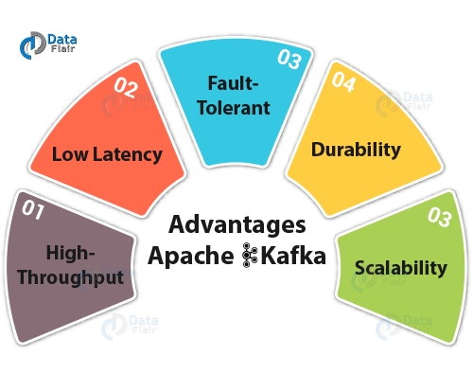](https://data-flair.training/blogs/wp-content/uploads/sites/2/2018/05/advantages-of-Kafka.png)

*Kafka Interview Questions & Answers- Advantages of Apache Kafka*

* **High-throughput**

We do not need any large hardware in Kafka, because it is capable of handling high-velocity and high-volume data. Moreover, it can also support message throughput of thousands of messages per second.

* **Low Latency**

Kafka can easily handle these messages with the very low latency of the range of milliseconds, demanded by most of the new use cases.

* **Fault-Tolerant**

Kafka is resistant to node/machine failure within a cluster.

* **Durability**

As Kafka supports messages replication, so,  messages are never lost. It is one of the reasons behind durability.

* **Scalability**

Kafka can be scaled-out, without incurring any downtime on the fly by adding additional nodes.

**Q.9 What are main APIs of Kafka?**

**Ans.** Apache Kafka has 4 main APIs:

1. Producer API
2. Consumer API
3. Streams API
4. Connector API

**Q.10 What are consumers or users?**

**Ans.** Mainly, **Kafka Consumer** subscribes to a topic(s), and also reads and processes messages from the topic(s). Moreover, with a consumer group name, Consumers label themselves.

In other words, within each subscribing consumer group, each record published to a topic is delivered to one consumer instance. Make sure it is possible that Consumer instances can be in separate processes or on separate machines.